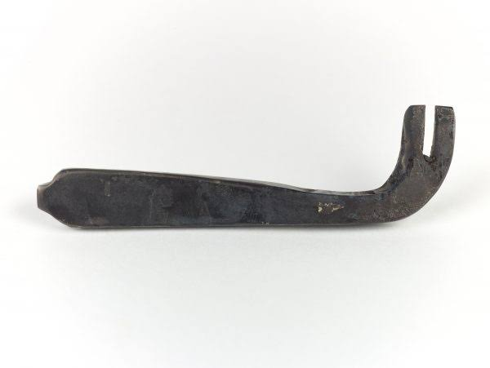Reproduction Iron Key

An iron key based on one found at Repton, Derbyshire

An iron key based on an original found in Grave 511 at Repton, Derbyshire.  Iron keys were not only practical items but also symbols of status. Women were often given keys to the families chests of valuables. They also are often buried with keys, representing their authority in the household.